Smart Parking based on IOT

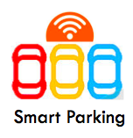

|  |  |
| --- | --- |
| **Prof** | *Lina Mroueh* |
| **Data** | *05/ 06/ 2017* |
| **Group** | *5* |
| **Members** | *WANG Jing*  *WANG Zhi*  *WANG Miaojie*  *YANG Xiaoxiao*  *ZHENG Shuqi* |

# 

Contents

General architecture description

location and description

Solutions to different scenarios

Selected technologies and characteristics of selected radios

Image recognition

Infrared sensing technology

Pressure sensing technology

Radios

RFID (Radio Frequency Identification)

ZIGBEE

LTE (Long-Term Evolution)

Short range and long range radio planning

Short range radio planning

Long range radio planning

Daily traffic relating to message exchanges

Management of temporary tenants

Marketing strategies

Network costs and expected profit

Network costs

Expected year of profitability

Economy situations in 5 years

Subscriber numbers

Benefits and costs of the company

Distribution of the task

# General architecture description

Nowadays, parking spaces are becoming increasingly scarce. In order to preserve the green space in the city center, our company finds a solution to set up a smart parking system located in the underground of residential area.

## location and description

We found that in an ordinary parking place of residential area, there are always a great number of vacant spaces during the weekend and vacation. That’s precisely the peak time for parking in the business zone. Therefore, we want to solve this problem and increase the utilization level of parking in the residential area: not only the permanent residents can park. Our smart parking is also open to other people who come to nearby restaurants, cinemas or shopping malls.

Specifically, a common size of residential area in Shanghai is about 50,000 m2, parking area is located on the underground and has one floor. There are about 1,000 families, we set 1,000 permanent parking spaces. Considering this residential area is located in the city center of high human traffic, we set 500 parking spaces for temporary using. ( The detailed information is shown in the table below)

|  |  |  |  |
| --- | --- | --- | --- |
| Size of residential area(m2) | 50,000 | number of floors | 1 |
| size of a spot(m2) | 13 | number of permanent parking space | 1,000 |
| Size of parking area(m2) | 30,000 | number of temporary parking space | 500 |
| total parking spots | 1500 | fee of temporary parking | 2€/hour |

In order to encourage more people to provide their parking spaces when they leave their homes, the temporary rent will be given to the residents partially.

We also use camera and RFID authentication to ensure our system is secure.

## Solutions to different scenarios

We use website to show information about parking spots for temporary tenant and permanent resident. Any changes will be informed by SMS (Phone numbers have been already known when they created accounts)

Permanent resident will have a permanent RFID card which is corresponded to a fixed parking spot and a key box. The resident shall have the right to decide whether to rent their spots, he needs to indicate on the website when he won’t use his spot, system can assign this spot to temporary tenant according to this time. If he needs to use his spot during this time, he has to check the status on website , if there is a car in the spot, system will distribute a new spot.

For temporary tenant, firstly, he needs to specify the time to leave, system will allocate a spot in the temporary parking spots. If it is full, system will find a permanent spot for it. Then, he will get a temporary RFID card and he needs to put his key in the key box. Part of the parking fee will be paid directly to the owners of the spot. if he doesn’t pick up his car on time, agent will park their cars to a new place, new place will be informed by SMS and website. He also needs to pay extra for a timeout.(regularly, double the fee)

Agent of our company has the highest priority: he has the universal access to all key boxes and is responsible for moving overtime cars to a new spot.

# Selected technologies and characteristics of selected radios

## Image recognition

Cameras are placed in the entrance and exit of parking lot for recording vehicle information(License plate and car models), the system will distinguish between different vehicles by the image recognition and vehicle-related information will upload to the database.

## Infrared sensing technology

More than two infrared sensors are placed in each parking spot to determine the spot is empty or not. If at least two infrared sensors are covered, the parking spot will be seemed as occupied.

## Pressure sensing technology

Pressure sensor are placed in the key box to detect whether the key is placed or not.

## Radios

### RFID (Radio Frequency Identification)

1. Real-time capability
2. Anti-falsification
3. Accuracy
4. Low-cost
5. Reliability
6. RFID cards don't require batteries and can be reused

### ZIGBEE

ZigBee is a mesh network protocol. It is designed to carry small data packets over short distances while maintaining low power consumption. The reason we choose Zigbee are listed below.

1. Low power consumption, two AA batteries can work for 6 to 24 months
2. Low cost
3. Low rate
4. Close range
5. short delay
6. High capacity
7. Unlicensed band

### LTE (Long-Term Evolution)

Communication between mobile phones and data terminals.

1. high speed
2. high capacity (supports at least 200 clients in every 5 MHz cell )
3. flexible spectrum

# Short range and long range radio planning

Size of the parking area is 40,000m2

Number of parking spots is 1,500

## Short range radio planning

zigbee: 1500

RFID tag: 1,500

RFID reader: 10

RFD:1500

FFD:10

## Long range radio planning

long range radio will be based on local communication operator

# Daily traffic relating to message exchanges

The large capacity of the parking spots, located in residential areas, means that our system must deal with a lot of information exchange, while ensuring that the information is secure.

Cameras are placed in the entrance and exit collect the car’s information, including the license plate number, car models, entering time, leaving time.The system identifies between permanent residents and temporary tenants through image recognition. Temporary tenants gets RFID card at entrance.

The communication between car and the our system can be divided into 3 cases:

1) Permanent residents enter parking lot (every resident has a fixed parking spot), camera will detect the plate number while server find the location of parking spot and open the key box for residents. After infrared sensors detecting the car has been parked, reducing function device (RFD) receive sensor data and send to FFD by zigbee. Resident leave the car and put the key in box. Pressure sensor detect changes in electrical signals, and then send data to final function device (FFD) by zigbee, then FFD send collected data to server by cable. The server always upload current information to website so that clients can check their parking state.

2) Temporary tenant can’t enter parking directly like PR because the plate number is not in database, so system will distribute one spot and supply one RFID card(At the same time one parking space only corresponds to one plate number and one RFID card). The screen placed on the corner will guide the driver to their parking. The plate number, location and direction information will be displayed until the car is in right spot. Tenant must drive the car to assigned spot, if they do not, the RFID can not open the key box. Tenant has one temporary account on website with the RFID card, and tenant can know the current location(if it is changed), parking duration and parking fee. We also support online payment.

Compared with resident account, temporary account has limited activities. Administrator has authority to manage cars and priority of permanent user. Tenant has to give the RFID card back and pay the fee at key box, there is a POS near the key box.

3) The administrator main job is moving cars. The residents can manage parking spots through website, they also can ask the administrator to move the car parked in the parking spot before they come back. If residents forget to remind in advance, system will require the administrator to move temporary car when residents enter parking. Actually the system will arrange free parking spots based on their parking habits, which will reduce the workload of administrator to save labor costs.

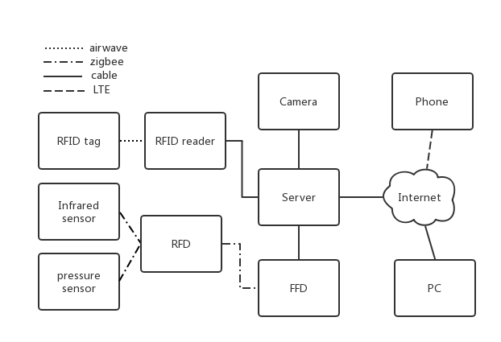

# 

# Management of temporary tenants

Unit payment: 2€/hour.

Reputation value(100/100 points):

According to this value, system can judge whether this temporary tenant can park in here or not. Initial value is 100, when temporary tenants park their cars overtime, minus 5 points/time. On time leaving, plus 5 points/time. People whose value is under 50 points will pay 3€/hour. People whose value is equal to 0 can’t park in here.

# Marketing strategies

Residents can choose whether to rent their spots or not when it frees. Company will charge the fee and share 60% to the residents. Which means we have more spots for Temporary tenants and extra income for residents.

Join parking union to upload the information about our situation, guide people to other parking area when we are full, reduce parking pressure in other parking area when we have free spots.

Advertise the features of our smark parking area.

# Network costs and expected profit

## Network costs

|  |  |  |  |
| --- | --- | --- | --- |
|  | quantity | univalence(€) | total price(€) |
| Camera | 2 | 300 | 600 |
| Screen | 12 | 200 | 2400 |
| Parking lot gates | 2 | 400 | 800 |
| Key box | 10 | 100 | 1000 |
| Server | 2 | 2500 | 5000 |
| Reducing function device | 1500 | 2 | 3000 |
| Full function device | 10 | 25 | 250 |
| RFID tag | 1500 | 0.1 | 150 |
| RFID reader | 10 | 40 | 400 |
| Infrared sensor | 6000 | 3 | 18000 |
| Pressure sensor | 1500 | 2 | 3000 |
| Cable | 10000(m) | 0.02 | 200 |
| POS | 10 | 120 | 1200 |
| EXTRA | / | / | 10000 |
|  |  | total: | 47500 |

Maintenance cost: 3000 €/year

Salary of agents: 2000€ per person per month

numbers of agents:5

Electricity bill: 2000€/month

## Expected year of profitability

**Permanent resident**:50€/month (Management costs).

50€*12*1000=600,000€ /year

**Temporary tenant**: Considering not all of the spots will be used in the same time and it won’t be used for 24h. So 50% of spots for tenants will be paid in 5h/day.

2€*5h*365*500*50%=912,500€/year

In these conditions, our parking will profit in the **first** year.

# Economy situations in 5 years

## Subscriber numbersPoints scored

The number of temporary parking subscribers in the first year is about 35,000 and it will increase year by year.

## 

## Benefits and costs of the company

The benefits conclude fees from permanent resident and temporary tenant as we have calculated it before, for the first year, we should pay for 200*30,000=6,000,000€ for the perpetual parking land, so we should input

6,000,000+3,000+2,000*5*12+2,000*12=6,147,000€

As all of the charge for management and maintain for the first year, .and from the second year, the costs just conclude the management charges, the maintain fees and the salary of agents, and it is 147,000€.

Increasing the number of tenant, income of our parking area will be also increased and the costs will be increased as well. (for example,if the person increased year by year, maybe we should set more than 147,000€ a year to ensure the devices, and also increase the numbers of agents, and their salaries )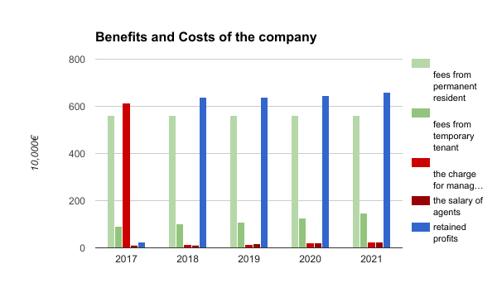

# Distribution of the task

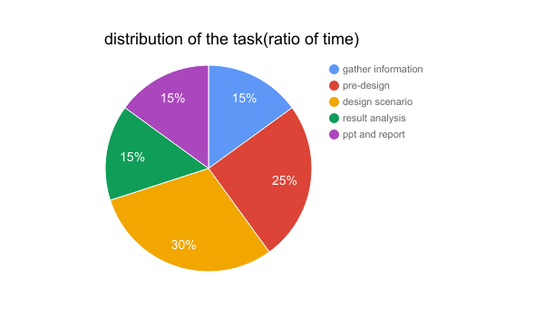

For distributing this huge task, we divide it to 5 parts, at the first period, we use 15% time, we search the internet for gathering information about the parking lot in China, especially in Shanghai, because it is one of the most representative city in China, and also has problem of scarce-parking.

During the 2nd period, it takes us 25% time, we focus on pre-design a scenario to solve the problem, we discuss together several times to make sure our project can be achieved.

At the 3rd part, after we make sure that everything is feasible, we spend 30% time to design architecture of our project, we consider a lot of problems which may happen to our life and try to solve them, every detail should be considered.

At the end, we concentrate on the result-analysis, it took us 15% time.

At the end of this project, we use 15% time to prepare the PPT and this report to show our achievement.

|  |  |  |  |  |  |
| --- | --- | --- | --- | --- | --- |
|  | gather information | pre-design | design scenario | result analysis | ppt and report |
| Wang Jing | √ | √ | √ |  | √ |
| Wang Zhi | √ | √ | √ |  | √ |
| Wang Miaojie | √ | √ | √ |  | √ |
| Yang Xiaoxiao | √ |  | √ | √ | √ |
| Zheng Shuqi | √ |  | √ | √ | √ |

## 